January 2023 CSE 216
Advanced SQL ONLINE - 2
Time: 45 minutes
As the newly appointed database expert (going to be) in the company with an Oracle database system, your CEO assigned you a crucial task. You were asked to extract specific information from the UNIVERSITY schema. Sample outputs have been provided. Observe carefully, your column names are expected to match the provided output’s column names.
1. Find the courses that have the highest enrollment count in each semester. Order the output according to year and semester.
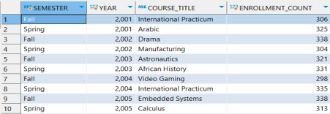
2. Find the distinct courses taught by instructors with at least 100 students receiving a grade of ‘A+’. You cannot use join in the main query. You must use SUB-QUERY in the where clause. You can use join in the sub-queries.
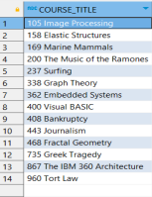
3. Find the distinct course IDs and titles that appear in either the "Comp. Sci." department or have a prerequisite in the "Math" department. You must use set operations. You cannot use any join operations. Order the output according to the department name.
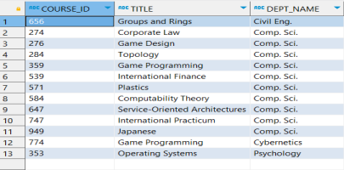4. Find the courses that have conflicting time slots (overlapping schedules).
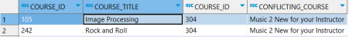
5. Find the instructors who have taught courses with enrollment counts higher than the average enrollment count of all courses in each semester. Your column names are expected to match the provided output’s column names.
